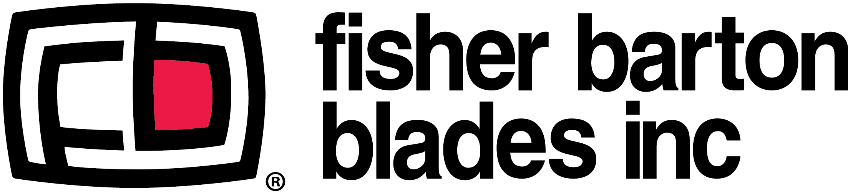
The Fisher Barton Group consists of eight world-class manufacturing companies (nine facilities with 900+ employees) that produce a wide range of products for multiple industries, including bronze gear blanks, lawn mower blades, agricultural wear components, industrial blades, thermal spray coatings, oil and gas components, and medical devices. Fisher Barton Blades, located in Watertown, WI, is the #1 manufacturer of lawn mower blades worldwide. Approximately 90% of the company is devoted to the production of more than 900 different rotary blade designs for original equipment manufacturers (OEM’s) each year.

Fisher Barton Blades in Watertown is hiring for the following positions:

- Press Room Operators
- Heat Treat Operators
- Straighteners/Packagers
- Material Handlers
- Tool & Die Makers
- Maintenance Mechanics
- Manufacturing Engineer
- Manufacturing Engineer Co-op

We offer competitive pay, health/dental/vision insurance, disability, life insurance, 401k w/company match, vacation, holidays, tuition reimbursement and more.
Equal Opportunity Employer/Drug Free Workplace/E-verify.

Apply in person or via email to: HR@fisher-barton.com.

Fisher Barton Blades
300 Air Park Drive
Watertown, WI 53094

